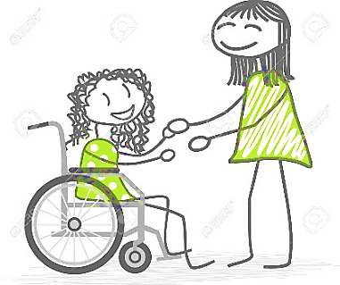
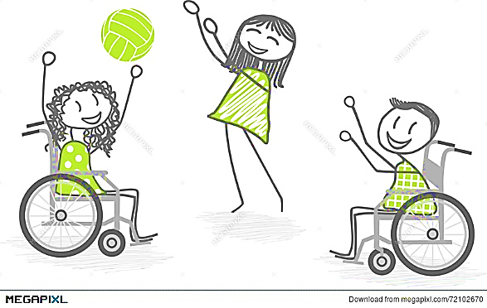
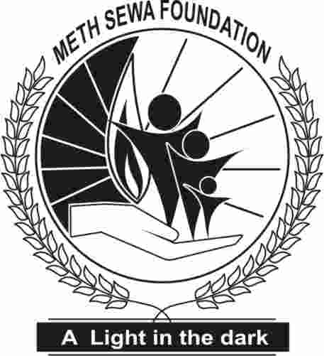

Meth Sewa Foundation

Sponsorship for special with needy person,
Creating a person with different abilities
Description of the Home of the Special with Needy Children
This Special with Needy children Home is situated in Handapanagala in the Southern Province of the Monaragala District of the Uva Province in the Divisional Secretariat Division of Wellawaya under the Registration No. We/V.O/27/2008,MSS/NSPD/R/194,G.A3299 Handapanagala is a rural area where farmer families live and who are under the low income group who live under government stamps.
We have children who reside in the home that are with mental and physical problems. These children cannot do their own work and even do their toilet duties without their knowledge and also the parents who cannot afford to give their own child the best of their needs in every aspect due to poverty that has stricken them.
Our Home has the motivation of giving these children food, shelter and comfort in their lives which they have never got in their lives from their parents or guardians.
This Home Meth Sewa Foundation was inaugurated in the year 2008 On a research done by the Residential Director himself had seen the lives of the poor and took steps to give his own residence for two inmates to start with for they had no one to care and in the year 2020 now we have 125 children from the ages of 1 year to 80 years old that reside in the home. This Home is a of great merit and also a Charity Organization and a Non Profitable Organization (NPO) The main objective is to give these children food, clothing, shelter and medical treatment etc. no matter of caste creed race and nationality.
These children were given to us from the Social Service Department , court of law, Probation Office, Police, Hospitals and also children thrown on streets and done away from their own kith and kin This home is run by Alms, given by the neighbors and others who are willing to give Alms to these children to ensure that these children have a meal for the day.

Our Mission for the Special with Needy Children
Every child has the right to live a happy life what ever state and circumstances they are live in and To give special place and comfort especially to the mentally and physically handicapped and who are unwanted by the world as they are valuable and done away by their own kith and kin.

Our Vision at Meth Sewa Foundation
Creating a better future for the Special with Needy Children and To give special attention and care and to be on the alert to give the needs for the unwanted by giving them Medical Treatment, Food, Clothing and also training them and giving them a Vocation Training and making them eligible to be good citizens and to ensure that they are valuable to the world.
Children that reside at Meth Sewa Foundation
From Ages | Female | Male | Total
02 Years & below  02 To 06  07 To12  13 To18 | 01  04  10  09 | 01  05  14  07 | 02  09  24  16
Under 18 years | 24 | 27 | 51

19 To 25  26 To 60  Over 60 Years | 06  29  02 | 09  28  02 | 14  57  04
Over 18 years | 37 | 39 | 76

Under 18 years Over 18 years | 24  37 | 27  39 | 51  76
Full Total | 61 | 66 | 127

There are children that can help the home in some way to assist the other workers. We have also started a Vocational Training for children who like to sew making of small items and knit under the Supervision of a well Trained Teacher and these things made by the children are on display for visitors to see.

Description of Daily Expense
Meals
We have 127 children We get alms for birthdays, memorials anniversary and any other occasions but we have to cook the breakfast for 15 days of the month and 5 days we have to cook for lunch and 13 days we have to cook the dinner the reason is sometimes due to personnel problems people do not bring alms or else some do forget to bring the alms to the home. So we have to cook meals at a time when it is necessary.
Baby Food
From these 127 children that reside in the home there are children who are kids and some who cannot swallow food due to some kind of inability of eating food so we need cereals, milk products rusks for these type of children so that we could easily feed them.
Tea Time
Most of the children are under medical treatment and are weak due to the medicines they take and they get epilepsy fits so they need a lot of nourishment and due to that milk foods such as milk, sugar, tea and coffee. The other children in the home loves to have a cup of milk tea as they greedily await for a cup of tea.
Allowances Caregivers
There are 11 persons as staff working in the home. Out of the 11 persons 5 of them reside in the home. These workers have problems in their own life and due to the reasons of their problems stay in the premises. Their salary is given to them by the work they are given and now due to the Courantyne it is difficult to give them their salary. We need 05 more staff members as we have 85 children who do their toilet duties without their knowledge and also when the child get sick there should be one or two attend hospital.
Transport
We have children under treatment in the Government Hospitals on clinical books given by the hospitals but sometime some of the children get sick and have to be rushed to the hospital due to illness that prevails. Transport is necessary to transport to and from hospital.
Amenities
We have to use electricity for the children during the night due to the kids especially as they also need to be attended during the nights when they cry and also they children suffer from epilepsy fits.
Water is mainly use as these children most of them do their toilet duties without their knowledge and have to be washed and cleaned as they be very offensive. We also have to use the water to clean the place and wash the areas which is dirty so as to give the children a better environment and a better odors.
Telephone and mobile is necessary to do correspondence and to talk and confirm about alms etc.

Stationary
We need stationary for office purposes as we have to write to the alms givers and also send letters to various department when necessary and to keep records on other work in the Office.
Medicines
We get medicines from the Government hospital but, some of the medicines are not available in the hospital and we have to purchase it from the pharmacy and it is very expensive.
Maintenance
We have to maintain the building in the premises as when taps are broken because these children are mentally and physically handicapped the children who are mentally handicapped do help us in small chores of work but sometimes very careless so when taps are broken we have to repair and also we have to maintain the buildings when breakages are around the home.
Expenses chart for the Special with Needy Children at Meth Sewa Foundation
Category Needed | Monthly cost without donation
Breakfast | 56,700.00
Lunch | 37,800.00
Dinner | 49,140.00
Baby Food | 20,000.00
Milk Powder | 49,100.00
Tea | 17,400.00
Coffee | 21,000.00
Sugar | 8,700.00
Allowanced Caregivers | 290,000.00
Electricity | 39,000.00
Water | 15,000.00
Telephone Land line | 8,000.00
Telephone Mobile | 3,000.00
Transport | 18,000.00
Stationary | 8,000.00
Medicines | 15,000.00
Maintenance | 10,000.00
Full Total for the month | 665,840.00
Monthly Expenses For per Child an average Ammount | 5,284.44

Development of the Organization……………………………….
Meth Sewa Foundation started from a small building and now it has expanded in a wide range of buildings to have buildings for the boy’s girls and also for the kids that reside in the home. In completion of the buildings in the home we have the Shrine area with a decorative atmosphere. On the next is the Main Office where information could be got of Special with Needy children and also where the staff could get to work on their daily routine. Thereafter the Conference hall where a meeting is held monthly for the staff to discuss various ways to make this home a success. The next is the Pharmacy where medicines are stored and is call the Osu Sala
We also have a Water Filter that is to give drinking water for the inmates as this area most people suffer from Kidney disorders the old building should be rebuilt and to make it more comfortable for the children is our motive.
Information and about the staff………………………………………
The Sole Proprietor or may call the Residential Director is Mr. V.G.W. Niroshan of Meth Sewa Foundation . He on a research program in the area had gone deep to find the whereabouts of these children who are mentally and physically handicapped and thereafter giving two children to live in the premises and this Organization developed in a vast manner and he himself gave his own home to the Special with Needy Children He has a staff of 11 persons who are kind and very alert at any given time. The staff feeds, bathe, washing of clothes, cut their hair and to do the duties given to them. We have our doctors who visits us from the Government Hospital to give the inmates the medical treatment needed for their health. Each child has a file that consist of their health and of their daily treatment When there is no Alms the staff is on the alert to cook for the inmates and not keep them hungry.
How you could help the Home ………………………..
Every year we get alms from people in order to celebrate their birthdays, anniversary or a memorial in remembrance of the dead Another way of giving meals in by giving us rations to enable us to cook a meal for the inmates in the home. You too could give alms to these inmates who deserves in either a meal rations or else a 10 O clock tea or evening tea that they would like to have with something special. These children also like to receive gifts as they do not get gifts from the outside world.
We are mostly in need of to make Meth Sewa Foundation a steady and a more comfortable atmosphere to give the best to our children life. We need your help to give these children a better life. We require rations, disinfectant, medicines, house hold equipment, accessories office stationary all these things could be donated by communicating with us to find out our needs and the things we require for the home. You could also help Meth Sewa Foundation in groups so that to paint the walls of the home in a more suitable atmosphere to give the children a broad mind to study something that attracts their mind. You also come in groups to entertain these children in music and dance to make them happy.
If I have missed anything that is necessary for the home, please be good enough to promote it to us and advise us to enable to give our children the best in life.
Please also note that once you bank money in our account please notify it as soon as possible to enable us to acknowledge receipt in the name who funds us.
We are in need of things for the Special with Needy Children which is very important and necessary to give them a better life for their future.
The following are the needs for this Special Needy children

Medicines -:
We need medicines which we do not get from the hospitals as it is not available

Speech Therapy We require speech therapy to give this therapy to enable for the children to talk and to explain what their needs and wants

Physiotherapy we need a physiotherapist to do the exercise as to enable them to move their limbs and be of use for themselves.

Special Treatment and Advisory Programs to advise the children as they need to be given a lot of advice to enable them to be more calm and to be able to move in society. This is especially to have the children to have their own human rights as any other child should be given.

Education -:
To give these children education as to give them an education to learn to write, draw sing and dance and to use their abilities which have been hidden which they have not used in their life.

Special Education Vocation Training To give them a training in vocational training entertainment to enable to change these children’s and make use of their Human Resources for they are very potentially proven to use their ability at this type of work.

Donation by money and bank details ……………….
Name of Bank :Bank of Ceylon, wellawaya Branch
Account No :76207004
Name of account :Meth Sewa Foundation
Information……………………..
By post : Meth Sewa Foundation, Handapanagala, Weherayaya
Telephone No :0713385005 (Mr.Niroshan) Founder of Meth Sewa Foundation
0552055005 (Office working Hours: 8 a.m. to 5.30 p.m.)
E mail address : methsewafound@gmail.com
Web site : methsewa.org
Face book account :Meth Sewa Needy child
Google map : :https://www.google.com/maps/place/Meth+Sewa+Foundation/@6.658975,81.139063,16z/data=!4m5!3m4!1s0x0:0xd97b0615179207c1!8m2!3d6.658975!4d81.1390626?hl=en
Help these poor innocent children and kids for they are unwanted by the world and their own kith and kin. Could you kindly if you wish to be a sponsor for these children for three months or six months or for one year. Please inform us so that we could send details of the children and also note that we do not like to make our children social with the out side world.. You could also send us the message through whats app on the mobile number for further details.
God bless you and guide you in abundance for when you give to the poor you are rewarded from the Almighty who made Heaven and earth.

